Vehicle-to-Home Energy Management: A Simulation Tool for Assessing Flexibility, Savings and Self-Sufficiency
Cécilia Lebarbey, Tim Marentič
University of Ljubljana, Faculty of Electrical Engineering
Tržaška cesta 25, 1000 Ljubljana, Slovenia
Email: cecilia.lebarbey@groupe-esigelec Tim.Marentic@fe.uni-lj.si

Abstract:
This paper presents a simulation tool designed to explore residential Vehicle-to-Home (V2H) energy strategies under diverse real-world conditions. Built with a visual and user-friendly interface, the tool enables quick scenario testing based on parameters such as season, location, vehicle type, and user behavior. It calculates key performance indicators including self-sufficiency, flexibility, and cost savings, using realistic demand, PV generation, and dynamic tariff profiles.
The tool was evaluated through targeted test cases and internal user testing involving energy experts. Results confirmed its ability to reflect contextual variations and support both technical analysis and educational use. A comparative study also revealed that larger EV batteries do not always yield better performance under short connection periods.
By making complex energy interactions accessible without requiring advanced modeling skills, the simulator serves as a valuable support tool for researchers, students, and local stakeholders involved in energy transition planning.
- Introduction

The increasing share of renewable energy in power systems calls for greater flexibility. At the same time, electric vehicles (EVs) are emerging as a growing but underused source of distributed energy storage. As transportation becomes increasingly electrified, the correlation between traffic patterns and electricity demand is also intensifying, revealing new interactions between the energy and mobility sectors.
Among Vehicle-to-X (V2X) solutions, Vehicle-to-Home (V2H) stands out as a promising approach. It enables direct energy exchange between an EV and a household, with potential benefits such as improved self-consumption of solar energy, lower electricity bills, and reduced stress on the electrical grid.
Despite this potential, only a few simulation tools currently exist to explore V2H strategies in realistic conditions. Most are either embedded in complex research frameworks, limited to specific use cases, or not publicly accessible. This project addresses that gap by developing an intuitive and open simulation tool tailored for quick scenario testing and educational use.
The tool is designed to support cross-country
comparisons, seasonal variation, and diverse user behaviors, making it suitable for both exploratory analysis and communication purposes. It offers a visual, parameter-driven interface that calculates key performance indicators such as flexibility, savings, and self-sufficiency.
This article introduces the simulation tool and details its structure and underlying logic. We then explore selected scenario-based test cases, present a comparative analysis of battery size impact, and share results from internal testing and expert feedback. The conclusion discusses the broader value of such tools in research and teaching, as well as future development opportunities.

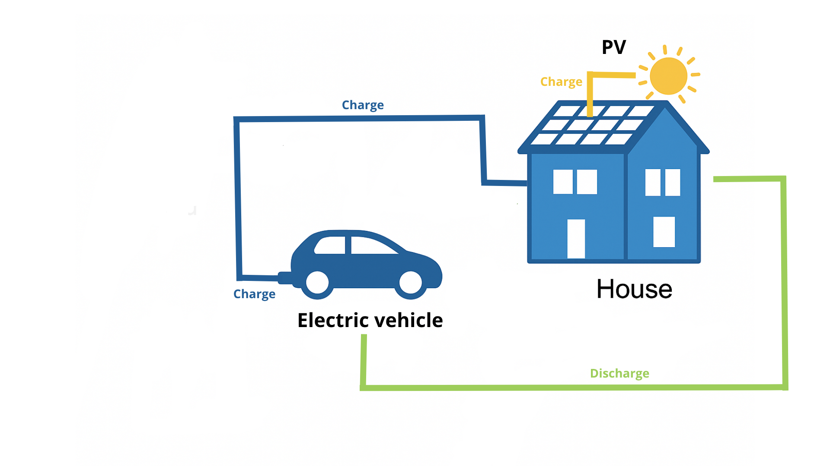
Figure 1. Energy flow diagram of a residential Vehicle-to-Home (V2H) system.
- Simulation tool and methodology

2.1 Simulation tool
We developed a Python-based simulator designed to model 24-hour energy exchanges in a Vehicle-to-Home (V2H) system with an hourly resolution. The system includes four interacting components: household electricity demand, photovoltaic (PV) generation, the electric vehicle (EV) battery, and the power grid. The simulation follows a rule-based logic that prioritizes self-consumption: PV energy is first used to supply household needs; if additional demand remains, the EV battery may discharge within its limits to help cover it. When there is surplus PV production or off-peak electricity from the grid, the EV battery is charged, as long as the target state of charge (SoC) at departure is
guaranted.
The simulator respects key technical constraints: a maximum bidirectional power flow of 11 kW, a minimum SoC of 20 %, and a user-defined target SoC depending on the selected scenario. Specific connection windows define when the vehicle is available to interact with the system. The output includes time series of SoC evolution, energy flows between entities, and a set of performance indicators (e.g., energy autonomy, cost savings, and flexibility).

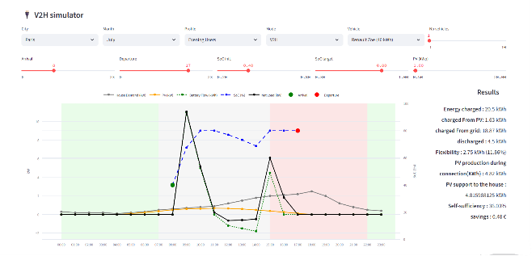
Figure 2: overview of the tool

2.2 Input data
The simulation is driven by realistic, context-aware input parameters. Hourly photovoltaic (PV) generation profiles are calculated from PVGIS irradiance data, assuming a panel efficiency of 20.5 %, and scaled according to the installed capacity specific to each city—typically ranging from 9 to 15 kWp depending on the scenario. When users select a location, the corresponding PV profile adapts automatically to reflect seasonal solar potential.
Household electricity demand is modeled using five behavioral profiles derived from the literature, such as the "Morning Glory" or "Average Day" user. These profiles capture diverse consumption patterns over a 24-hour period. They are defined as normalized hourly distributions and scaled to match a given daily energy consumption.
Electric vehicles included in the tool feature battery capacities ranging from 40 kWh to 80 kWh, all with a bidirectional power capacity of 11 kW. The state of charge (SoC) is constrained within strict operational boundaries: it cannot fall below 20 %, nor exceed 100 %. Users can customize the vehicle’s connection schedule—arrival and departure times—to reflect individual habits or fleet-level operation.
Time-of-use tariffs are defined for each city and follow a block-based structure, distinguishing off-peak, mid-peak, and peak periods. These dynamic electricity prices influence battery behavior when PV production is insufficient, allowing the system to pursue economic optimization while respecting technical and operational constraints.

2.3 Test case design
Five realistic use cases (UC1 to UC5) were designed to explore a broad range of user behaviors and technical configurations within a V2H context. These scenarios vary key parameters such as vehicle connection timing (arrival and departure), state-of-charge (SoC) constraints, seasonal conditions, and user objectives.
For instance, UC1 simulates a typical weekday home worker who connects the vehicle for an extended daytime period, while other use cases reflect different habits, such as shorter evening connections during winter (UC2), weekend-only availability (UC3), or operation as part of a shared mobility fleet (UC4 and UC5).
By systematically modifying these parameters, each use case helps assess how contextual factors influence the performance of V2H strategies. The scenarios were specifically chosen to test the simulator’s ability to capture variations in energy autonomy, available flexibility, grid interaction, and economic value. This structured approach enables the evaluation of both technical outcomes and user-centric benefits across a diverse set of real-world configurations.

2.4 KPIs
The simulation produces a set of key performance indicators (KPIs) that quantify both technical efficiency and economic outcomes. These include the total energy charged to and discharged from the EV battery (expressed in kWh), the respective contributions of photovoltaic production and the EV to covering household electricity demand, and the flexibility made available by the system—defined as the amount of energy the EV can shift in time to support the home or optimize costs.
Other important indicators include local self-sufficiency, calculated as the percentage of household demand met without relying on the grid, and total cost savings, expressed in euros, when compared to a baseline scenario in which the household consumes grid electricity exclusively. These KPIs provide a comprehensive evaluation of how V2H strategies perform in different contexts, allowing users to assess both the energy autonomy of the system and its economic viability under real-world constraints.
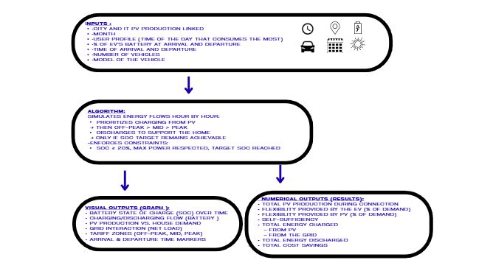
Figure 3 : How the algorithm works

3 Results : Case study, impact of the battery's size
To assess how battery size influences V2H performance, we conducted a comparative analysis using two different vehicle configurations under identical conditions. The test scenario simulated a summer day in Paris, with the EV connected from 19:00 to 11:00, starting at a 50 % state of charge (SoC) and aiming for 90 % by departure. All other parameters were held constant, including the household demand profile (UC2), a 9 kWp PV installation, and a dynamic three-tier tariff structure.
The only difference between the two cases was the battery capacity of the vehicle: one used a small EV (Renault Zoé, 40 kWh) and the other a large EV (BMW iX3, 80 kWh), both with the same 11 kW bidirectional charging capability. Despite the larger energy throughput recorded for the BMW (38.9 kWh charged vs. 22.9 kWh for the Zoé), the performance outcomes were remarkably similar. Both vehicles discharged exactly 6.9 kWh to assist the household, reached the same flexibility score of 45.4 %, and benefited equally from PV production during the connection period (24.11 kWh), with 19.21 % directly covering household consumption. The overall self-sufficiency rate was identical in both cases, reaching 86.3 %.
Interestingly, the smaller battery configuration resulted in slightly higher cost savings (0.92 € compared to 0.88 € for the larger battery), mainly due to reduced reliance on grid electricity.
These findings suggest that, under short connection durations and moderate solar input, increasing battery size does not necessarily improve performance. In such situations, charging needs dominate system behavior, and excess capacity often remains unused. Therefore, without longer availability windows or higher PV generation, oversizing the battery may lead to underutilized flexibility.
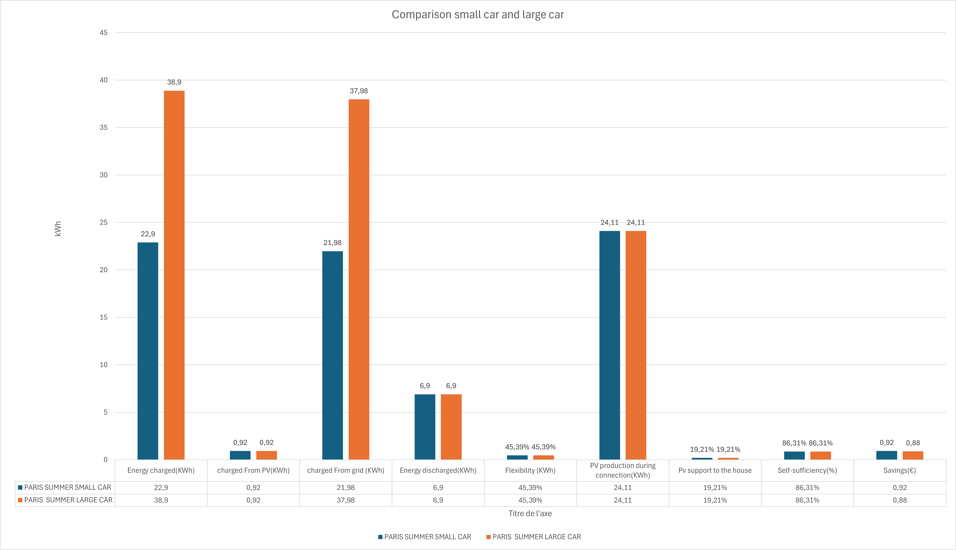
Figure 4 :. Impact of battery size on performance indicators for the same scenario (Paris, summer weekday).
4 Results : Internal testing, domain experts
To evaluate the simulator, five researchers and engineers from the University of Ljubljana (with expertise in energy systems but not involved in the tool’s development) participated in a structured user test. After a brief introduction, they simulated a predefined scenario where only the vehicle model could be changed, followed by three additional real-world use cases from the EV4EU project. These cases differed in season, connection times, and SoC targets, allowing participants to explore technical and behavioral impacts.
Participants analyzed both graphical outputs (e.g., battery flow, SoC evolution) and numerical KPIs (e.g., flexibility, self-sufficiency, savings). They then completed a short questionnaire combining factual and reflective questions. When asked which performance indicator improved the most in scenario UC3, most users identified flexibility as the key improvement (see Figure 5), consistent with the scenario’s longer connection and moderate PV production. Self-sufficiency and cost savings followed.
Overall, the simulator was positively received. Users appreciated the clarity of the visuals, the ease of use, and the ability to observe how different parameters affect results. All simulations produced coherent outcomes—for instance, higher PV usage and self-sufficiency in summer Athens, or greater grid reliance in Paris during winter.
Suggestions included adding tooltips for KPIs, enabling result export in table format, and extending the simulation window beyond 24 hours. One participant emphasized the tool’s potential for teaching energy flexibility and user impact in university courses.
Based on this feedback, several refinements were implemented. The simulator is now stable and ready for broader use within the EV4EU project and academic outreach contexts.
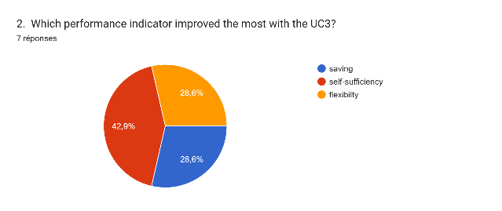
Figure 5: Most improved KPI in UC3, based on user responses

5 Discussion
The case studies confirm that user behavior, connection timing, and seasonal context all influence the performance of V2H systems. While all scenarios reduced grid dependency, gains in flexibility and savings varied. These results highlight the need for personalized strategies depending on usage patterns. Current limitations include the one-day simulation
window and simplified logic. Future improvements could add more realistic routines or integrate predictive control. Still, the tool already supports exploratory analysis and educational use across diverse contexts.

6 Conclusion
This article introduced a simulation tool designed to model and analyze residential Vehicle-to-Home (V2H) energy exchanges across different locations, seasons, and user profiles. The aim of the tool is to make scenario testing more accessible, particularly for non-specialists, while offering relevant performance indicators for both technical and economic assessment through a simple and visual interface.
Initial testing with domain experts confirmed its usability and conceptual consistency. Participants were able to interpret key trends, identify performance variations across scenarios, and provided constructive suggestions for future improvement. These insights contributed directly to refining the interface and validating the overall approach.
Compared to existing solutions, this simulator stands out for its flexibility, educational value, and ability to compare multiple contexts in a reproducible way. It allows for rapid testing of different vehicle types, user behaviors, and solar production levels, all within a coherent and user-friendly environment. The tool is therefore suitable not only for researchers and engineers, but also for students, designers, and local energy stakeholders seeking to explore V2H strategies without advanced modeling skills.
Acknowledgements
This work was carried out as part of the EV4EU project, with support from the Erasmus+ mobility programme.
Future developments may include multi-day simulations, aggregated EV fleets, or real-time data integration, enhancing the tool’s value for research, policy, and local energy planning.

References
[1] M. Marentič, et al. “Electric Vehicle Flexibility in Future Grids.” IEEE Trans. Smart Grid, 2022.
[2] A. Lopez, et al. “Modelling User Behavior for V2X Applications.” Energies, vol. 15, no. 7, 2023.
[3] M. Marentič, I. Mendek, K. Anžur, and M. Zajc, “Electric Vehicle Flexibility in Future Grids,” IEEE Transactions on Smart Grid, 2022.
[4] T. Marentič, I. Mendek, K. Anžur, and M. Zajc, “Bidirectional Power Exchange between Electric Vehicles and the Grid (V2G) for the Development of Flexibility Services with Aggregation of EV Fleet,” Electrotechnical Review, 2023.
[5] I. Mendek, T. Marentič, K. Anžur, and M. Zajc, “A Case Study on Electric Vehicles as Nationwide Battery Storage to Meet Slovenia’s Final Energy Consumption with Solar Energy,” 2024.

